+  

To Supply Leftover Food to Poor

# Project Overview

This project, ***To Supply Leftover Food to Poor***, is designed to tackle the logistical challenges of collecting, managing, and distributing leftover food to underserved communities. By leveraging the Salesforce platform, the solution streamlines key processes such as food collection coordination, volunteer management, and delivery to multiple drop-off locations. With real-time tracking and efficient data management, the project aims to optimize operational workflows, improve user experience, and ensure data accuracy. Ultimately, the goal is to reduce food waste while supporting vulnerable populations, fostering long-term sustainability, and contributing to the fight against hunger.

# Objectives

## Business Goals:

* + **Establish a Scalable and Efficient System for Managing Surplus Food Donations**.
  + Optimize Logistics and Coordination Across Collection Points, Volunteers, and Distribution Channels.
  + Implement Real-Time Tracking and Analytics for Data-Driven Decision-Making.

## Specific Outcomes:

* + Creation of Custom Objects and Relationships for Data Tracking.
  + Real-Time Reporting System for Food Distribution Metrics.
  + Interactive Dashboards for Visualizing Key Metrics.

# Salesforce Key Features and Concepts Utilized

This project leverages several Salesforce features to optimize data management and streamline operations, including:

* **Custom Objects**: Created specialized objects such as Venue, Drop-Off Point, Task, Volunteer, and Execution Details to efficiently track and manage data related to food donations, volunteer assignments, and logistics.
* **Apex Triggers**: Implemented custom Apex triggers (e.g., DropOffTrigger) to automate the assignment of distance values, ensuring efficient and accurate matching of volunteers and drop-off points.
* **Lightning App and Custom Tabs**: Developed the FoodConnect Lightning App to centralize all relevant objects and streamline navigation, enhancing user experience and operational efficiency.
* **Sharing Rules**: Configured sharing rules based on distance criteria, ensuring appropriate access control for users based on their proximity to specific drop-off points or venues.

# 4. Detailed Steps to Solution Design

The design and development process followed a structured approach to ensure the platform met the project’s goals efficiently:

* **Data Modeling**: Designed and created custom objects (e.g., *Venue*, *Drop-Off Point*, *Task*, *Volunteer*, *Execution Details*) with the necessary fields and relationships (Lookup and Master-Detail) to establish a strong data structure and support efficient data tracking and reporting.
* **User Interface Design**: Developed custom tabs for easy access to key data, integrating them into the *FoodConnect Lightning App* to ensure smooth navigation and an intuitive user experience for all stakeholders.
* **Business Logic Implementation**: Built the *DropOffTrigger* using Apex to automatically calculate and populate the *Distance Calculation* field, ensuring seamless assignment of volunteers based on proximity to drop-off points and improving operational efficiency.
* **Screenshots:**

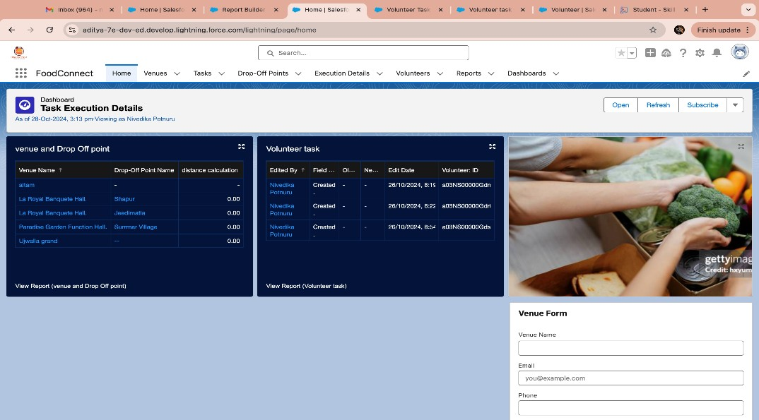 **Screenshot of the UI**

## Likhitha Add Screenshot of the Flow

## 

**5. Testing and Validation**

The testing process was structured to ensure system functionality, performance, and user experience.

* **Unit Testing**: Performed thorough testing of Apex classes and triggers, with a particular focus on the *DropOffTrigger* and the automation of custom field updates to ensure accuracy and reliability.
* **User Interface Testing**: Validated the usability and functionality of all UI components, ensuring smooth data flow and seamless interaction across custom tabs and within the *FoodConnect Lightning App*.

# 6. Key Scenarios Addressed by Salesforce in the Implementation Project

* **Scenario 1: Coordinating Food Collection and Distribution:**  
  Organized drop-off points and matched them with nearby sharing groups.
* **Scenario 2: Volunteer Tracking and Assignment:**  
  Tracked volunteer availability to assign them efficiently for food collection and delivery.
* **Scenario 3: Feedback and Reporting:**  
  Collected volunteer feedback, ratings, and delivery data to improve future service.

# 7. Conclusion

In summary, the initiative to supply leftover food to those in need has achieved several key outcomes: it has effectively reduced food waste, ensured the efficient redistribution of surplus food to underserved communities, and strengthened support for vulnerable populations. These efforts contribute to food security, foster community resilience, and promote a more sustainable approach to resource management.